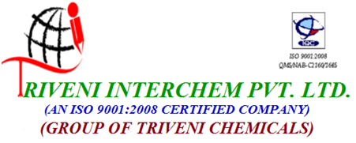
134 Pancharatna Char Rasta G.I.D.C.,Vapi.396195 Gujarat India

Tel-Fax No. 91- 260 - 6618618, 09227788155,Fax No. 91- 260 - 6618624
Email: info@trivenichemical.com,Website:www.triveniinterchem.com

Technical Data Sheet

Material: Propylene Glycol

General Information:
CAS No.: 57-55-6
Formula: C3H8O2
Synonyms: 1,2-Propanediol

Technical Data:

Items | Unit | Specifications | Result
Apperance |  | Liquid, Colourless | Complies
Colour | Pt-Co | ≤30 | 8
Purity | % | ≥98.0 | 99.47 %
Water | % | ≤1.0 % | 0.53 %
Ph |  |  | 6.55
SP. Gr. |  |  | 1.02

Characteristics:

Propylene Glycol is a viscous, stable, hygroscopic liquid. It is essentially colorless and has a slight odor and a very slight acid taste. Propylene glycol is completely miscible with water and many organic solvents and will dissolve a number of resins, dyes and essential oils.

Applications:

The principal end uses of PG include coolants, industrial solvent, chemical intermediate, cosmetics, pharmaceuticals, food and tobacco products, paints and coatings. It is available in Industrial and USP grades.

Health & Safety Information:

Observe good industrial hygiene practices and use appropriate Personal Protective Equipment. For full safety information please refer to the Safety Data Sheet.

